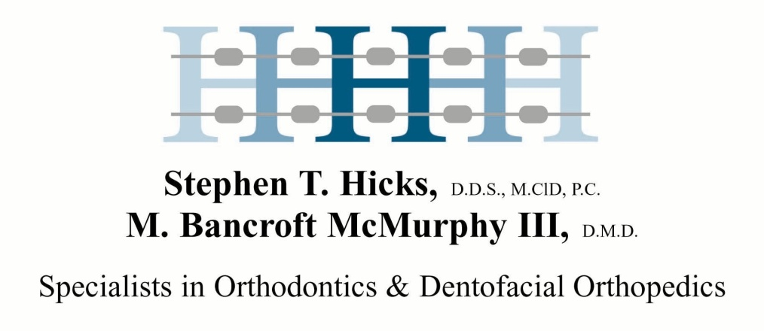
Sponsor Request Form

Hicks & McMurphy Orthodontics not only supports families in the community by creating beautiful smiles, but we also support local clubs, area schools, and charitable organizations through sponsorship advertising. We are happy to fund these activities and events, however since we do receive so many requests, we ask that you please submit a Sponsorship Application Form and that you follow these guidelines:

- Please submit all requests through the Sponsorship request form below.
- Requests must be received at least 30 days prior to the deadline, allowing us to randomly choose quarterly recipients on March 15, June 15th, September 15th, and December 15th. If your sponsor commitments are before these dates, then we will have to decline your requests. However we encourage you to send in an application for a later quarter.
- Please only submit a request once per year.
- Please do not call the office regarding your request, will contact the patients/organizations that have been chosen in a random drawing at the quarterly deadline dates.

Due to the overwhelming number of requests that we receive each year, first priority will be given to patients that are currently in Orthodontic treatment. We regret that we are unable to support every request but we look forward to receiving your applications and will do our best to help your organization.
Please submit your completed form and email it to info@hicks-mcmurphyortho.com, or mail it to:

Hicks & McMurphy Orthodontics
Attn: Sponsorship Request
1575 University Blvd South
Mobile, AL 36609
Sponsorship Application Form

Date
Patient Name Phone# ( )
Your Name (if different from patient)
Address
Email
Patient Treatment Status
Organization/School
Type of Sponsorship (please check one) Program Sign Ad
Cost & Size of Sponsorship
Due Date
Who should artwork or ad be mailed to?
Who is check payable to?
Who should check be mailed to?
Please tell us how you are involved with the organization and why you would like us to sponsor it/additional comments
Please attach any other pertinent information to this form and drop it off at our office, email it to info@hicks-mcmurphyortho.com or mail it to:

Hicks & McMurphy Orthodontics
1575 University Blvd
Mobile, AL 36609

